**MESD LMS Documentation – View content from external repository**

**Purpose**

Allow learners to access external file sources where they can bring content into Moodle from the external sources.

**Usage**

1. Log in as a **Learner**.
2. Go anywhere on the site that requires file submissions e.g assignments, your private files, blogs.
3. Click on the **Files** icon.
4. View content from available repositories.

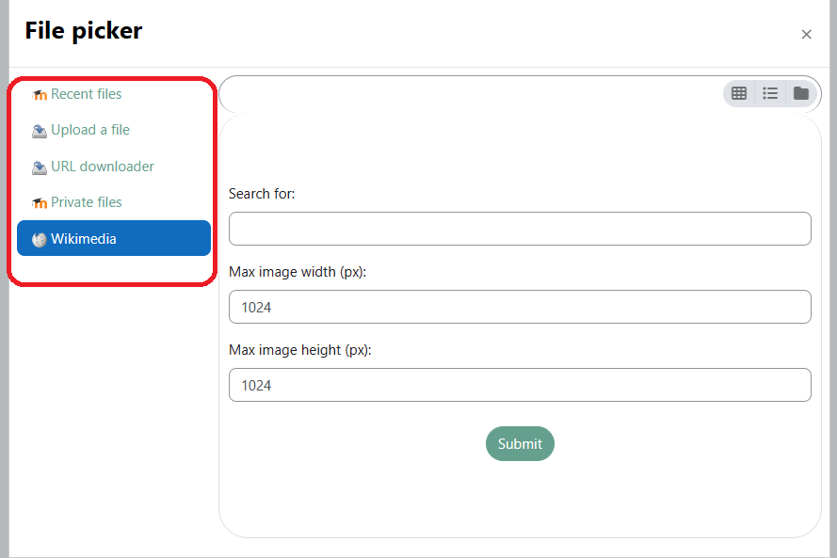

There are 4 file sources.

1. **Recent files** shows all the files that you have uploaded on the site in your courses/private files recently.

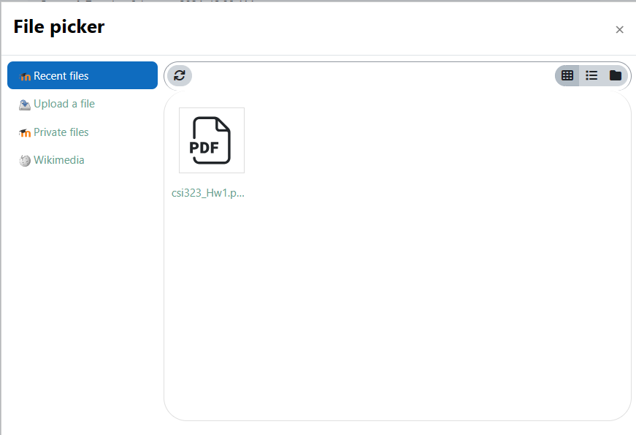

1. **Upload a file** uploads files from local storage.

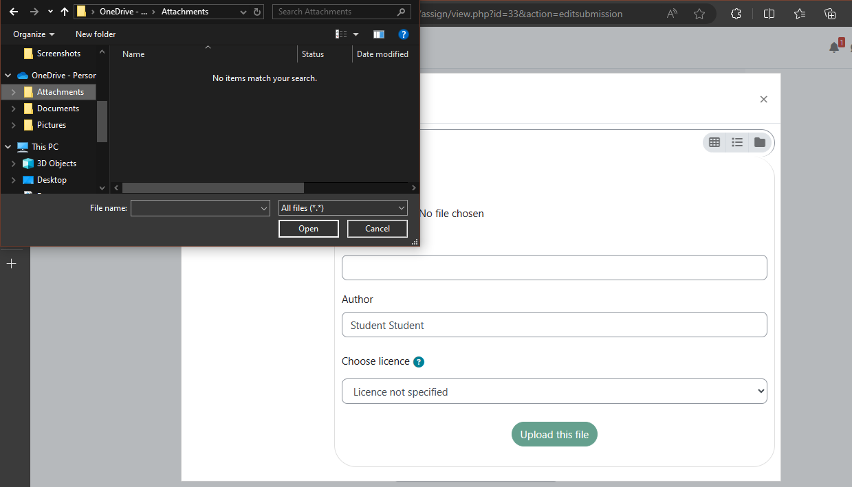

1. **URL downloader** downloads content provided in a URL. This is only available in **Private files**.

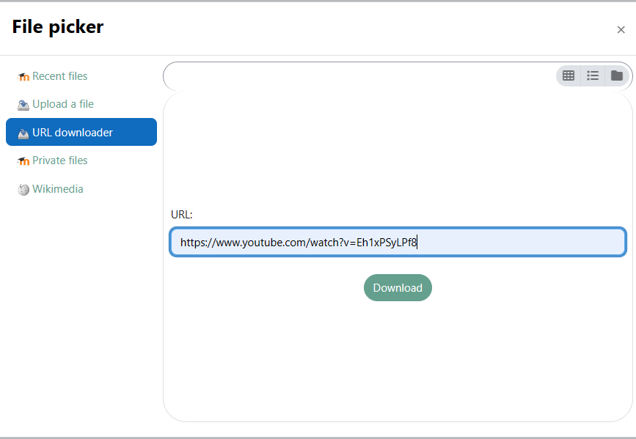

1. **Private files** are files that you uploaded to your learner profile. Only you can access them.

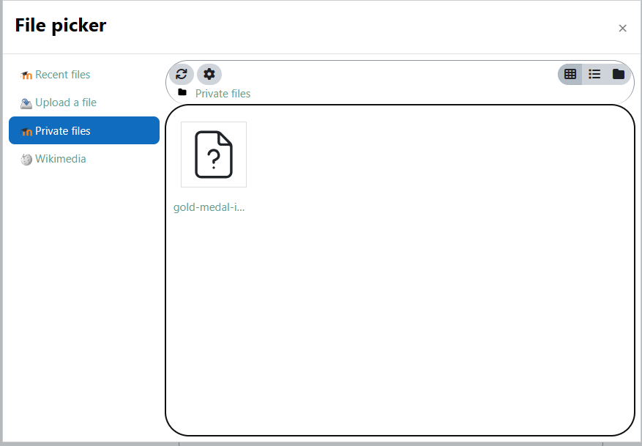

1. **Wikimedia** allows you to look up pictures found on Wikipedia.

